Chapter 9, Problem 60.

Obtain Z_{in} for the circuit shown in Fig. 9.67.

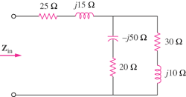

Figure 9.67
For Prob. 9.60.

